 | 
AIM Enhancements – Phase I
Business Specifications Document


AIM AON for Simple Orders

Final Version
Date: 21st November 2007

Table of Contents

1 AIM AON Auction Specifications for Simple Orders 3
1.1 General Business Rules 3
1.2 ‘AON Solicitation Minimum Quantity’ Trading Property 3
1.3 All-or-None (AON) Contingency 4
1.4 AIM AON for Simple Orders – Auction Execution Scenarios 6
1.4.1 Start of Auction 6
1.4.2 During Auction 7
1.4.3 End of Auction 7
1.4.3.1 Premature End of Auction 7
1.4.3.2 Normal End of Auction 7
1.4.3.3 Allocations at End of Auction 7
1.4.3.3.1 Allocation Scenario 1 7
1.4.3.3.2 Allocation Scenario 2 (without Customer Orders) 8
1.4.3.3.3 Allocation Scenario 3 (with Non-AON Customer Orders) 8
1.4.3.3.4 Allocation Scenario 4 (with AON Customer Orders) 8
1.4.3.3.5 Allocation Scenario 5 (only Auction Responses) 9
1.4.3.3.6 Allocation Scenario 6 (only Auction Responses) 9
1.4.3.3.7 Allocation Scenario 7 (with Customer Orders) 9

AIM AON Auction Specifications for Simple Orders

General Business Rules
- After the AIM AON auction is started, an AIM order with ‘A:AIR; will be treated the same as an AIM order with ‘A:AIM’.
- Auto-match is not allowed. Hence if MO is MKT then the system should not accept the order (i.e. reject with an indication in the GUI itself)
- ‘Auction Minimum Quoters’ trading property does not apply to AIM AON.
- NBBO checks not required for AIM AON.
  - Auction Starting Price to be considered of the BBO and Matched Order price.
  - The AIM Orders can trade-through NBBO as the quantity is greater than 500.
- If the Matched Order is of ‘F’ origin type then the Primary and Matched Orders must not be having the same Give-up Firm. After the AIM Order is submitted both the Primary and Matched Orders must be CANCELLED.

‘AON Solicitation Minimum Quantity’ Trading Property
A new trading property ‘AON Solicitation Minimum Quantity’ must be created.
- The trading property must be configurable by ‘Trading Session’ and ‘Product Class’.
- The default ‘AON Solicitation Minimum Quantity’ value is 500
- Only orders with ‘AON Solicitation Minimum Quantity’ EQUAL to or GREATER than X (500) must be eligible (i.e. in addition to other AON criteria being satisfied) for the AON Solicitation Mechanism.

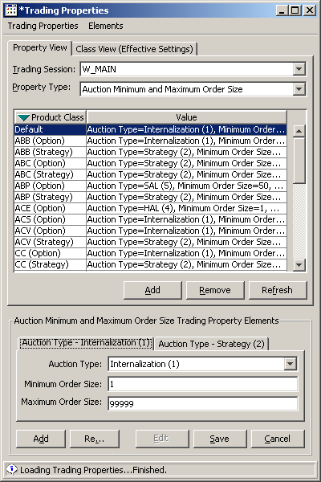
New trading property of ‘AON Solicitation Minimum Quantity’
Will just have ‘Order Size’ element.

(Note: This screen shot is not accurate and is provided for illustrative purposes only)

All-or-None (AON) Contingency
Only in product classes where ‘AON Solicitation Minimum Quantity’ is equal to or greater than X (500), the system must allow to submit an order with the ‘AON’ contingency type.
- The AON contingency type must be allowed for both the Primary and Matched Orders.
- For AON Solicitation Mechanism to work both the Primary Order and Matched Order must be AON.
- If the Primary Order is AON and the Matched Order is AON then
  - If the Primary Order quantity is EQUAL to or GREATER than ‘AON Solicitation Minimum Quantity’ then the system must perform the AON Solicitation Mechanism
  - If the Primary Order quantity is LESS than ‘AON Solicitation Minimum Quantity’ and
    - If A:AIM, then CANCEL both the Primary and Matched Orders
    - If A:AIR, then CANCEL the Matched Order and route the Primary Order to TPF (Note: the routed Primary order retains the AON contingency)
- If the Primary Order is not AON and the Matched Order is AON then
  - If A:AIM, then CANCEL both the Primary and Matched Orders
  - If A:AIR, then CANCEL the Matched Order and route the Primary Order to TPF
- Irrespective of the Primary Order being either AON or not AON, if the Matched Order is not AON then the system must perform the regular AIM only.

(Note: For the purpose of AIM, the Primary Order is always treated as an AON order.)

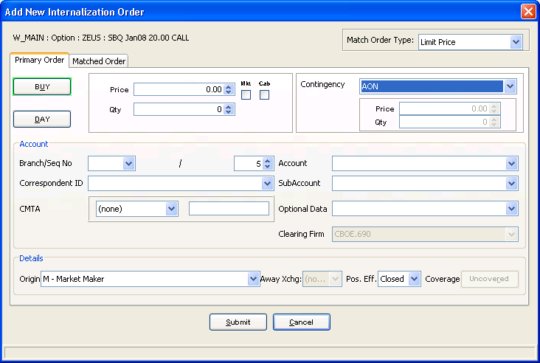

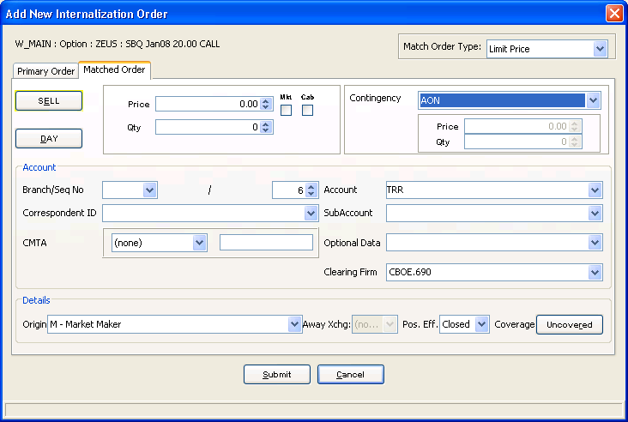

AIM AON for Simple Orders – Auction Execution Scenarios

Start of Auction
At the starting of the AIM AON auction, if there is a Customer Order at the Matched Order price resting on the opposite side of the Primary Order and
- If the Customer Order quantity is enough then AIM AON must start but
  - If there is no price improvement then PO trades with CO
    - If the CO is AON with quantity greater than PO quantity then PO trades-through the CO.
  - If price improvement through collective and enough quantity then PO trades with collective
  - If price improvement through collective and not enough quantity then
    - If A:AIM, then CANCEL both the Primary and Matched Orders
    - If A:AIR, then CANCEL the Matched Order and route the Primary Order to TPF (i.e. after auction starts A:AIR must be treated the same as A:AIM)
  - If price improvement only through Auction Responses and not enough quantity then PO trades with CO
- If the Customer Order quantity is not enough then AIM AON must start but
  - If there is no price improvement or if there is price improvement through collective and not enough quantity or if there is price improvement only through Auction Responses and not enough quantity then
    - If A:AIM, then CANCEL both the Primary and Matched Orders
    - If A:AIR, then CANCEL the Matched Order and route the Primary Order to TPF (i.e. after auction starts A:AIR must be treated the same as A:AIM)
  - If there is price improvement through collective with enough quantity then the Primary Order trades with the collective.

(Note: From the current regular AIM implementation, if a paired order is submitted where either the Matched Order’s price is worse than BBO or the quantity is not enough then both the Primary and the Matched Orders are immediately CANCELLED.)

During Auction
There are no new business rules different from the regular AIM for Simple Orders w.r.t. incomings during the AIM AON auction. Hence there are no modifications in rules for either prematurely ending the auction or allowing the AIM AON auction to continue and expire normally.

End of Auction

Premature End of Auction
Same rules apply as for prematurely ending the regular AIM auction. There are no modifications.

Normal End of Auction
Same rules apply as for normally ending the regular AIM auction. There are no modifications.

Allocations at End of Auction
At the end of the AIM AON auction, the AIM Order will either TRADE or CANCEL as detailed below.

Allocation Scenario 1

Auction Responses + Quotes + Orders are at a BETTER price than Matched Order and have enough quantity
Optional Data | Orders | Result
A:AIM or A:AIR | Primary Order | TRADED
 | Matched Order | CANCEL
 | Auction Reponses | TRADED
 | Quotes + Opposite Orders | TRADED
Auction Responses + Quotes + Orders are at a BETTER price than Matched Order but do NOT have enough quantity
Optional Data | Orders | Result
A:AIM or A:AIR | Primary Order | CANCEL
 | Matched Order | CANCEL
 | Auction Reponses | CANCEL
 | Quotes + Opposite Orders | UNAFFECTED

Allocation Scenario 2 (without Customer Orders)

Auction Responses + Quotes + Orders are at SAME price as Matched Order and have enough quantity
Optional Data | Orders | Result
A:AIM or A:AIR | Primary Order | TRADED
 | Matched Order | TRADED
 | Auction Reponses | CANCEL
 | Quotes + Opposite Orders | UNAFFECTED
Auction Responses + Quotes + Orders are at SAME price as Matched Order but do NOT have enough quantity
Optional Data | Orders | Result
A:AIM or A:AIR | Primary Order | TRADED
 | Matched Order | TRADED
 | Auction Reponses | CANCEL
 | Quotes + Opposite Orders (Non-Customer) | UNAFFECTED

Allocation Scenario 3 (with Non-AON Customer Orders)

Auction Responses + Quotes + Orders are at SAME price as Matched Order and have enough quantity
Optional Data | Orders | Result
A:AIM or A:AIR | Primary Order | TRADED
 | Matched Order | CANCEL
 | Auction Reponses | TRADED
 | Quotes + Opposite Orders (Customer) | TRADED
Auction Responses + Quotes + Orders are at SAME price as Matched Order but do NOT have enough quantity
Optional Data | Orders | Result
A:AIM or A:AIR | Primary Order | CANCEL
 | Matched Order | CANCEL
 | Auction Reponses | CANCEL
 | Quotes + Opposite Orders (Customer) | UNAFFECTED

Allocation Scenario 4 (with AON Customer Orders)

Incoming Customer Order is AON and is either EQUAL or BETTER than MO price and has quantity SAME as PO then MO is CANCELLED and PO trades with the Customer Order
Optional Data | Orders | Result
A:AIM or A:AIR | Primary Order | TRADED
 | Matched Order | CANCEL
 | Opposite Orders (Customer) | TRADED
Incoming Customer Order is AON and is either EQUAL or BETTER than MO price and has quantity MORE than PO then PO trades through the Customer Order with MO
Optional Data | Orders | Result
A:AIM or A:AIR | Primary Order | TRADED
 | Matched Order | TRADED
 | Opposite Orders (Customer) | Either BOOKED or TRADED with the book

Allocation Scenario 5 (only Auction Responses)

Only Auction Responses are at SAME price as Matched Order and have enough quantity
Optional Data | Orders | Result
A:AIM or A:AIR | Primary Order | TRADED
 | Matched Order | TRADED
 | Auction Reponses | CANCEL
Only Auction Responses are at SAME price as Matched Order but do NOT have enough quantity
Optional Data | Orders | Result
A:AIM or A:AIR | Primary Order | TRADED
 | Matched Order | TRADED
 | Auction Reponses | CANCEL

Allocation Scenario 6 (only Auction Responses)

Only Auction Responses are at a BETTER price than Matched Order and have enough quantity
Optional Data | Orders | Result
A:AIM or A:AIR | Primary Order | TRADED
 | Matched Order | CANCEL
 | Auction Reponses | TRADED
Only Auction Responses are at a BETTER price than Matched Order but do NOT have enough quantity
Optional Data | Orders | Result
A:AIM or A:AIR
 | Primary Order | TRADED
 | Matched Order | TRADED
 | Auction Reponses | CANCEL

Allocation Scenario 7 (with Customer Orders)

Opposite sided incoming Non-Quote like Order is either marketable or is at MKT price and has enough quantity
Optional Data | Orders | Result
A:AIM or A:AIR | Primary Order | TRADED @ mid-point of Auction Starting Price and PO side market price
 | Matched Order | CANCEL
 | Opposite Orders (Customer) | TRADED @ mid-point of Auction Starting Price and PO side market price
Opposite sided incoming Non-Quote like Order is either marketable or is at MKT price but does NOT have enough quantity
Optional Data | Orders | Result
A:AIM or A:AIR | Primary Order | CANCEL
 | Matched Order | CANCEL
 | Opposite Orders (Customer) | TRADED with the book @ PO side market price and remaining quantity is routed away

